Report
The main goal of my project is to detect counterfeit banknotes using compressed features. This is a crucial task, helping combat fraud and help banks avoid losses.
Dataset can be described:
- The dataset has only 2 features
- The dataset contains only 1372 rows.
- Mathematical expectations and standard deviations of these 2 features = (0.433735, 2.842763), (1.922353,5.869047)
- In the dataset, the mean and standard deviation differ for two features, so these two features need to be standardized for the algorithm to perform better.
- The dataset only has two features, which is a good number for the k-means algorithm, as it doesn't work well with many features.
- In the figure, some groups of points can be separated into clouds.
- This is good for clustering.
- Also, no outliers are visible in the figure.
- Overall, the dataset is suitable for clustering, but the features need to be normalized.
The initial dataset is shown in the photo below.
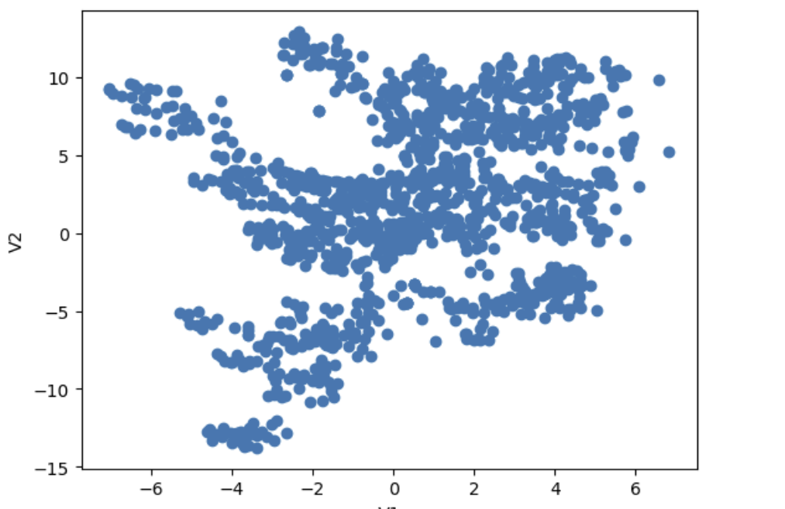
After analyzing the dataset, clustering was performed using the k-means method.
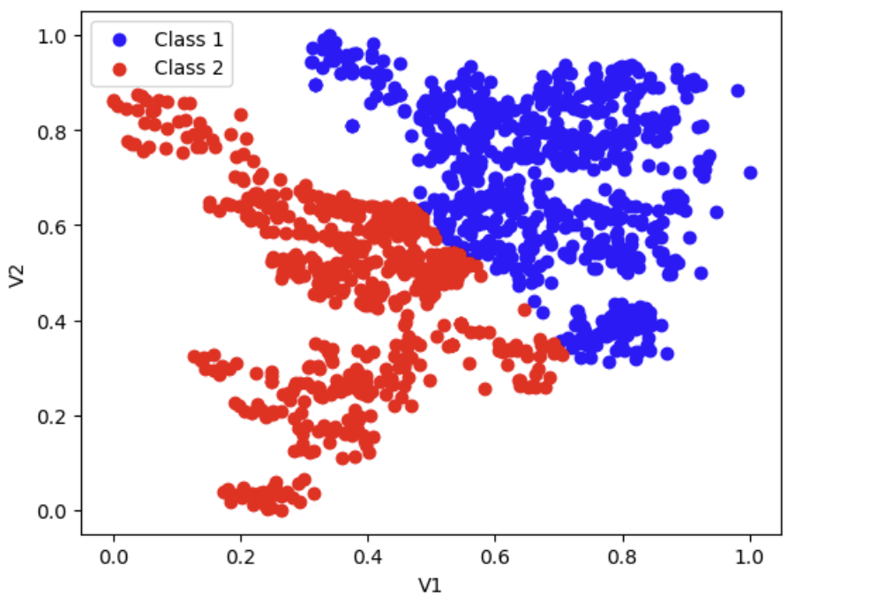
After this, 4 more experiments were conducted to ensure that the results were stable.
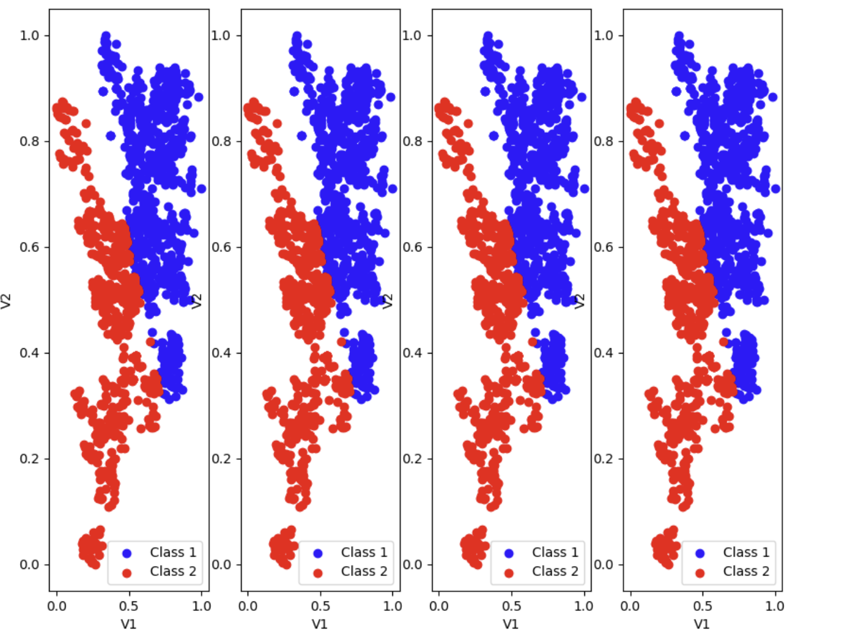
As a result of clustering, the points were divided into two groups. The points were separated approximately by the middle of the large cloud. During repeated tests, the clusters did not change significantly.
Based on the analysis conducted and the successful separation of the data into two groups using K-Means, it is recommended to formalize and strengthen the methodology to ensure the reliability of the detection system.

